Aj Shah

CS 3377.0W1

Nguyen

31 January 2019

**Project 1 Documentation**

The purpose of this program is to determine how many tokens are in a given command and what each token resembles.

1. Instead of using strtok, which would have been a smarter idea, but I realized too late, I used c_string and string methods in this program.
   1. The user inputs a command as a string.
   2. If the user inputs “QUIT” the program will end.
   3. The string is converted into an array of characters.
   4. 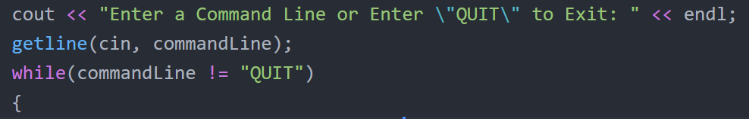This allows me to easily find and access specific characters in the command

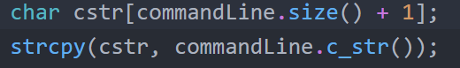

1. After the char array (cstr) was made, I used a for loop to determine the positions of all the spaces in the command. I stored the positions in an integer array called indexSpace
   1. The number of spaces plus one is the number of tokens in the command (not including single quotes, double quotes, etc.)
   2. 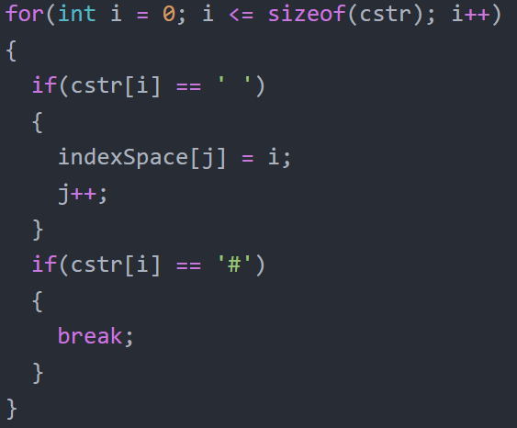The position of the spaces allow me to advance through the char array without having to start from the beginning each time. (Helps with efficiency)
2. Now that I have all the necessary information, I can loop through the char array and print specific information based on the character.
   1. 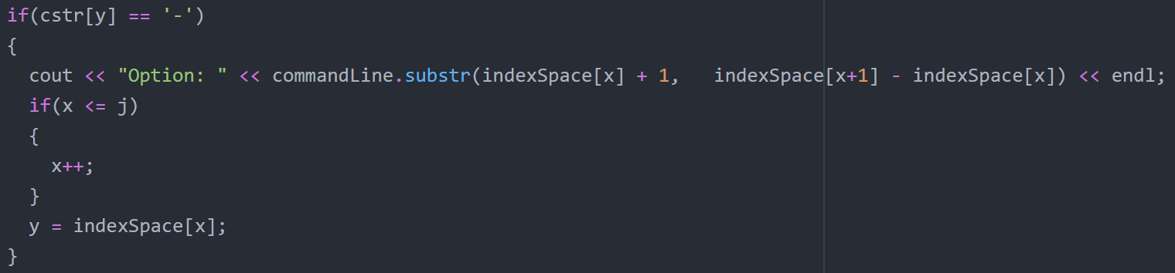Option (Starts with “-“)
   2. Pipe (Next word must be a command)

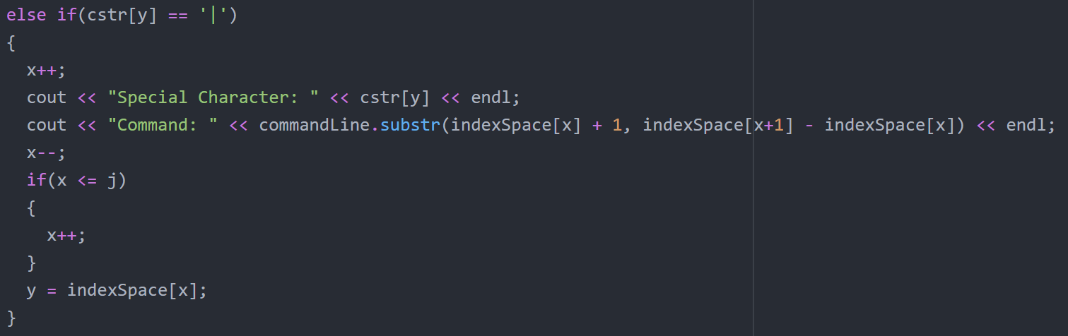

**How to Use it?**

Enter any Linux command and the program will return the token type and the number of tokens at the end. You can continue to enter a command, if you want to stop, enter “QUIT”.

**Program Issues**

1. Some of the bash commands interfered with my other commands. I attempted to implement all and it worked for certain commands, but it would cause the program to return incorrect information when entering other commands.
   1. Incompatible bash characters in the program: **$**, **“**, **\**, **!**, **;**, **~**
2. The program does not know the difference between ./home/desktop AND myfile.txt
   1. This may cause the program to return incorrect information for certain commands